Student Information Management System: A Console-Based Student Records System
---------------------------------------------------------------------

Introduction to Computing Project
Presented to the
Faculty of the College of Information Technology
Cagayan de Oro College
Cagayan de Oro City

-------------------------------------------------------------------------------

In Partial Fulfillment
of the Requirements for the Degree
Bachelor of Science in Information Technology

-------------------------------------------------------------------------------

NAME OF RESEARCHER

LAYONON, NOV
JAYOMA, JAEL Z
ROXAS, JAMES HEART
BENTILLO, MITCHELE R.
JUMALON, JOHN ARNIEL

OCTOBER 2026

  - Introduction
This system helps schools store and manage student records in one place. It can keep important details such as the student’s name, date of birth, year level, section, and other academic information. This is important in Philippine schools because correct student records help staff manage enrollment, classes, and learner information. DepEd uses the Learner Information System (LIS) to register learners in public and licensed schools, showing the importance of organized student data. Student records must also be protected because they contain private information. The National Privacy Commission states that student educational information is considered sensitive personal information under the Data Privacy Act of 2012.

The users of the system are the school staff, registrars, teachers, and students of PHINMA Cagayan de Oro College. In some schools, student records may still be written in notebooks, stored in folders, or saved in separate spreadsheet files. This can cause three problems. First, records may have wrong, missing, or duplicate information because staff may enter the same student details in different files. Second, finding a student’s record is time-consuming because staff need to check many papers or files. DepEd’s LIS includes search and masterlist features, which show that schools need quick access to learner records. Third, paper records and unprotected files may expose private student information to unauthorized people. Schools must properly protect student data because it is sensitive information.

The proponents developed the Student Information Management System: A Console-Based Student Records System. It is a Python console application designed for the authorized users of PHINMA Cagayan de Oro College — specifically registrars, students, and teachers. The system allows these users to manage and view student records according to their individual roles. These functions help keep information in one place, reduce duplicate or incorrect records, and make searching faster. The system also helps protect student information by allowing only authorized users to access the records based on their roles. Overall, the project provides a simple but useful way for PHINMA Cagayan de Oro College to manage student information more accurately, quickly, and safely.

  - Statement of the Problem
General Problem
Registrars, students, and teachers of PHINMA Cagayan de Oro College may experience difficulty managing and accessing student records when information is stored in paper files, notebooks, or separate digital files. This process can lead to incorrect or duplicate records, slow searching and updating of student information, and possible exposure of private student data. The proposed Student Information Management System: A Console-Based Student Records System aims to provide a simple and organized way for these users to manage and view student records more accurately, quickly, and securely according to their roles.
Specific Problems
The proposed project specifically addresses the following problems:
- Duplicate or incorrect student records – When student information is written in different files or updated manually, records may become incomplete, duplicated, or incorrect. This can cause confusion and affect the accuracy of school records.
- Time-consuming retrieval of student information – Registrars and teachers may spend too much time checking paper folders, notebooks, or separate files to find a student’s record. This can delay school transactions and daily office work.
- Risk to student data privacy – Paper records and unprotected digital files may be accessed by unauthorized persons. This can expose private student information and affect the confidentiality of school records.
  - Objectives of the Study
General Objective
The general objective of the proposed Student Information Management System: A Console-Based Student Records System is to develop a simple Python console-based application that helps the authorized users of PHINMA Cagayan de Oro College (registrars, students, and teachers) manage and view student records accurately, quickly, and securely according to their individual roles.

Specific Objectives
The project specifically aims to:
- To develop a function that reduces duplicate, incomplete, and incorrect student information.
- To implement a function that helps registrars and teachers quickly find and access student information according to their roles.
- To provide role-based access that allows students to view only their limited personal information, allows teachers to view only students in their assigned section, and allows the registrar to assign sections to teachers while protecting private student data from unauthorized access.
  - Scope
This project covers the development of a Student Information Management System: A Console-Based Student Records System. It is a simple Python console application made for the authorized users of PHINMA Cagayan de Oro College, specifically registrars, students, and teachers. The system is designed to work in a school office setting and will store all student records using dictionaries.

Individual Roles / Works of Users
- The registrar can fully manage student records by adding, updating, searching, viewing, and deleting student information. The registrar can also assign a section to a teacher so that the teacher can only view the students in that assigned section.
- The student can only view their own limited personal information, which includes name, date of birth, year level, address, contact number, email address, parents/guardian name, parents/guardian contact number, and parents/guardian home address. The student cannot add, update, delete, or view other students’ records.
- The teacher can only view the section assigned by the Registrar and can see the list of students and their information in that assigned section only. The teacher cannot view students from other sections and cannot add, update, or delete any student records.
- Data Covered the system can store and display student details such as student name, student ID number, age, gender, date of birth, year level, section, address, contact number, email address, parents/guardian name, parents/guardian contact number, and parents/guardian home address.

  - Limitations
The proposed system has the following limitations:
- The system is console-based and does not have a graphical user interface or a web-based interface.
- The system is designed only for the authorized users of PHINMA Cagayan de Oro College (registrars, students, and teachers). It does not provide access to parents or users outside the school.
- Student records are stored only in dictionaries while the program is running. The system does not use a centralized online database or permanent file storage.
- The system does not support simultaneous access by multiple users.
- The system does not provide real-time notifications, email notifications, or SMS notifications.
- System security is limited to User ID validation and role-based access control.
- Teachers are restricted to viewing only the students belonging to the section assigned to them by the Registrar.
- Students are restricted to viewing only their own limited personal information (Name, Date of Birth, Year Level, Address, Contact Number, Email Address, Parents/Guardian Name, Parents/Guardian Contact Number, and Parents/Guardian Home Address).
  - System Requirements
Hardware Requirements
The system requires the following hardware:
- Computer or laptop with at least an Intel Core i3 processor, AMD equivalent
- At least 4 GB of RAM.
- At least 500 MB of available storage space.
- Keyboard and monitor or display.

Software Requirements
The system requires the following software:
- Operating System: Windows 10 or Windows 11
- Python Version: Python 3.10 or higher
- Development Environment: Visual Studio Code or Python IDLE
- Storage: Text file (.txt)

Functional Requirements
The system shall allow the following users of PHINMA Cagayan de Oro College to perform these functions based on their roles:
- Registrar — Add a student record by entering the student’s ID number, name, age, gender, date of birth, year level, section, address, contact number, email address, parents/guardian name, parents/guardian contact number, and parents/guardian home address. Search, update, delete, and view all student records. Assign a section to a teacher. Receive clear validation messages when invalid or incomplete information is entered (such as duplicate student ID).
- Student — View only their own limited personal information Name, Date of Birth, Year Level, Address, Contact Number, Email Address, Parents/Guardian Name, Parents/Guardian Contact Number, Parents/Guardian Home Address.
- Teacher — View only the section assigned to him/her by the Registrar. View the list of students belonging to the assigned section. View the information of the students in the assigned section only.

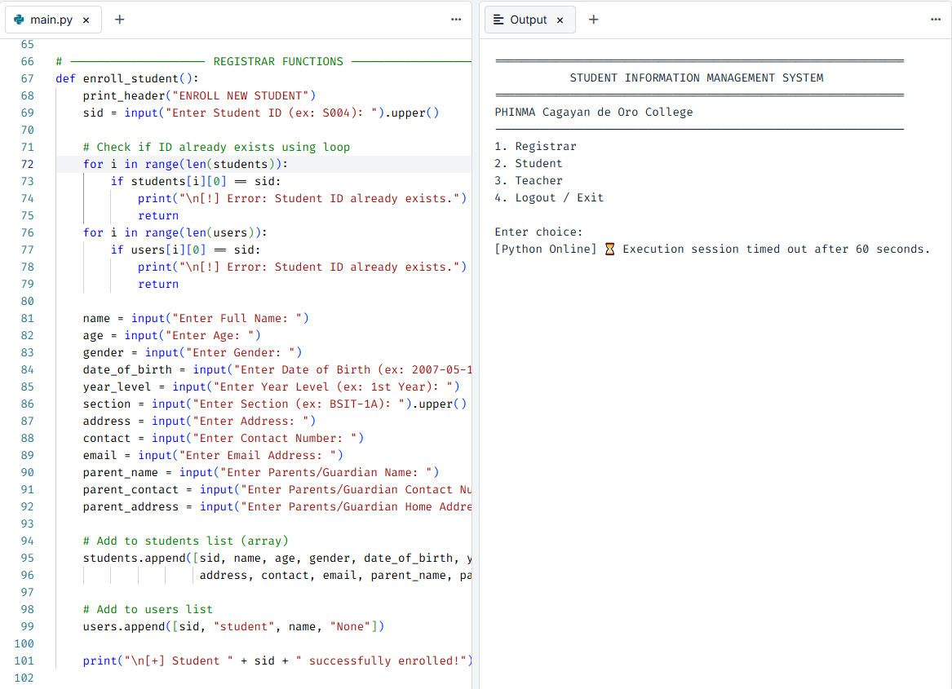
  - Code Snippet: Student Enrollment

This code allows the Registrar to add a new student record. It collects the student’s ID, name, age, gender, date of birth, year level, section, address, contact number, email address, parents/guardian name, parents/guardian contact number, and parents/guardian home address. It also uses a for loop to check whether the student ID already exists before saving the record, helping prevent duplicate student information.

Snippet 1 – Enroll New Student
Related Objective: Specific Objective 1 – Record and update student information to reduce duplicate, incomplete, and incorrect student records.
Purpose: This function demonstrates how the Registrar records a new student’s information and prevents duplicate student IDs using list and loop.

def enroll_student():
print_header("ENROLL NEW STUDENT")
sid = input("Enter Student ID (ex: S004): ").upper()

# Check if ID already exists using loop
for i in range(len(students)):
if students[i][0] == sid:
print("\n[!] Error: Student ID already exists.")
return
for i in range(len(users)):
if users[i][0] == sid:
print("\n[!] Error: Student ID already exists.")
return

name = input("Enter Full Name: ")
age = input("Enter Age: ")
gender = input("Enter Gender: ")
date_of_birth = input("Enter Date of Birth (ex: 2007-05-12): ")
year_level = input("Enter Year Level (ex: 1st Year): ")
section = input("Enter Section (ex: BSIT-1A): ").upper()
address = input("Enter Address: ")
contact = input("Enter Contact Number: ")
email = input("Enter Email Address: ")
parent_name = input("Enter Parents/Guardian Name: ")
parent_contact = input("Enter Parents/Guardian Contact Number: ")
parent_address = input("Enter Parents/Guardian Home Address: ")

# Add to students list (array)
students.append([sid, name, age, gender, date_of_birth, year_level, section,
address, contact, email, parent_name, parent_contact, parent_address])

# Add to users list
users.append([sid, "student", name, "None"])

print("\n[+] Student " + sid + " successfully enrolled!")

Explanation:
The function uses a for loop to check if the Student ID already exists in the list. If the ID is new, the complete student information is added to the students list using append(). This supports Specific Objective 1 by preventing duplicate records and storing student data in an organized array.

Snippet 2 – Student Limited Profile View
Related Objective: Specific Objective 3 – Provide role-based access that allows students to view only their limited personal information.
Purpose: This function shows how a student can only view selected personal details using list and loop.

def view_student_own_profile(student_id):
index = -1
for i in range(len(students)):
if students[i][0] == student_id:
index = i
break

if index == -1:
print("\n[!] Student record not found.")
return

s = students[index]
print_header("MY STUDENT PROFILE")
print("Name : " + s[1])
print("Date of Birth : " + s[4])
print("Year Level : " + s[5])
print("Address : " + s[7])
print("Contact Number : " + s[8])
print("Email Address : " + s[9])
print("Parents/Guardian Name : " + s[10])
print("Parents/Guardian Contact : " + s[11])
print("Parents/Guardian Address : " + s[12])
print_line()
print_line()

Explanation:
The system uses a for loop to find the student’s record in the list. Only the allowed personal information is displayed. This supports Specific Objective 3 by limiting what the student can see.

Snippet 3 – Assign Section to Teacher + Teacher View
Related Objective: Specific Objective 2 and 3 – Help teachers quickly access only the students in their assigned section.
Purpose: This code shows how the Registrar assigns a section to a teacher and how the teacher views only the students in that section using list and loop.

def assign_section_to_teacher():
print_header("ASSIGN SECTION TO TEACHER")

# Show available sections using loop
print("Available Sections in the system:")
print_line()
sections = []
for i in range(len(students)):
sec = students[i][6]
if sec not in sections:
sections.append(sec)
print(" - " + sec)
print_line()

# Show teachers using loop
print("List of Teachers:")
for i in range(len(users)):
if users[i][1] == "teacher":
print("Teacher ID : " + users[i][0])
print("Name : " + users[i][2])
print("Current Section: " + users[i][3])
print_line()

teacher_id = input("Enter Teacher ID to assign section: ").upper()

t_index = -1
for i in range(len(users)):
if users[i][0] == teacher_id and users[i][1] == "teacher":
t_index = i
break

if t_index == -1:
print("\n[!] Teacher ID not found.")
return

new_section = input("Enter Section to assign: ").upper().strip()
users[t_index][3] = new_section

print("\n[+] SUCCESS! Section " + new_section + " assigned to " + users[t_index][2])

def teacher_view_section(teacher_id):
t_index = -1
for i in range(len(users)):
if users[i][0] == teacher_id:
t_index = i
break

assigned_section = users[t_index][3]

print_header("MY ASSIGNED SECTION")

if assigned_section == "None" or assigned_section == "":
print("You have no section assigned yet.")
return

print("Assigned Section: " + assigned_section)
print_line()

count = 0
for i in range(len(students)):
s = students[i]
if s[6].upper() == assigned_section.upper():
count += 1
print("Student ID : " + s[0])
print("Full Name : " + s[1])
print("Date of Birth : " + s[4])
print("Year Level : " + s[5])
print("Section : " + s[6])
print_line()

if count == 0:
print("No students found in section: " + assigned_section)
else:
print("Total students in your section: " + str(count))

Explanation:
The Registrar uses loops to display available sections and teachers, then assigns a section. The teacher also uses a for loop to display only the students belonging to the assigned section. This supports Specific Objectives 2 and 3.

References
- Department of Education. (2020). Learner Information System (LIS): Presentation for OBE 2020. DepEd.
- Department of Education. (2014). LIS users manual v1.2. DepEd Learner Information System Support.
- National Privacy Commission. (2020). Advisory Opinion No. 2020-046. National Privacy Commission.
- National Privacy Commission. (2022, January 17). Online learning guidelines issued to help protect student privacy and reduce data breaches in schools. National Privacy Commission.
- National Privacy Commission. (2024, July 22). Republic Act No. 10173: Data Privacy Act of 2012. National Privacy Commission.

